Learner’s Academy Project Specification Document

# Project objective:

To design and develop a backend administrative portal for the Learner’s Academy.

# Background of the problem statement:

Learner’s Academy is a school that has an online management system. The system keeps track of its classes, subjects, students, and teachers. It has a back-office application with a single administrator login.

# The administrator can:

* Set up a master list of all the subjects for all the classes
* Set up a master list of all the teachers
* Set up a master list of all the classes
* Assign classes for subjects from the master list
* Assign teachers to a class for a subject (A teacher can be assigned to different classes fordifferent subjects)
* Get a master list of students (Each student must be assigned to a single class)

There will be an option to view a Class Report which will show all the information about the class, such as the list of students, subjects, and teachers.

# Learner’s Academy Algorithm:

1. Create a jsp login file with the post method having username, password and login button.
2. Create login servlet write code in do post and set username and password statically. If the given username and password matches then redirect to welcome.jsp, else throw an error message and redirect to login.html. Provide username on session for security as it checks the credentials forevery login. (Add servlet api jar after creating a servlet.)
3. Welcome.jsp first checks if login was made by checking username, if done, it prints Welcome message and gives hyperlinks to dashboard.html and logout. If not, it redirects to login.html.
4. dashboard.html prints welcome message and gives hyperlinks to view class report and to logout.
5. In dashboard servlet, establish jdbc connection first and create tables for classes, subjects and teachers using sql queries. (Add mysql connector jar here) Insert values to subject table by using prepared statement. Create a table to map and assign teachers to subjects and insert values in it using prepared statement. Create students table using sql query.
6. Create a query which gives a class report including classes, subjects, teachers, students using inner joins in sql. Save the output in result set and print all rows in browser using while loop (

.next)

1. Create a logout servlet and if user wants to logout in step 2 or step 4, he will be logged out successfully and was redirected to login.html.

# Concepts Used:

1. Java Core concepts
2. Servlets
3. Session login and logout
4. Servlet Request dispatcher.
5. Exceptions
6. HttpServlet Request
7. HttpServlet Response
8. SQL
9. Tomcat
10. JSP
11. HTML

# Tables used:

**Subjects table:**

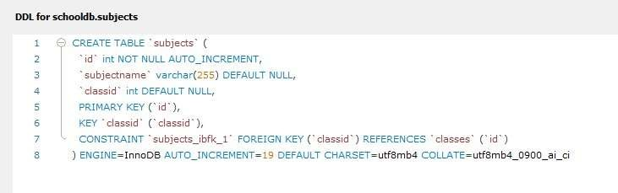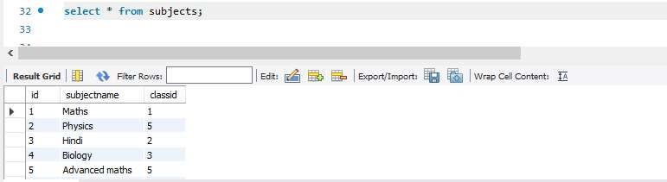

**Teachers table:**

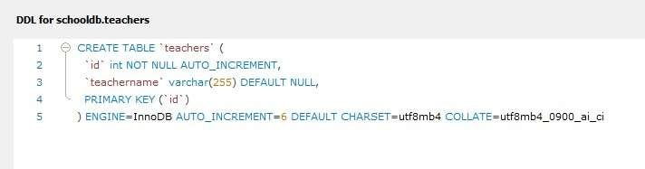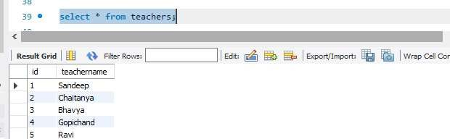

**class_subject_teacher table:**

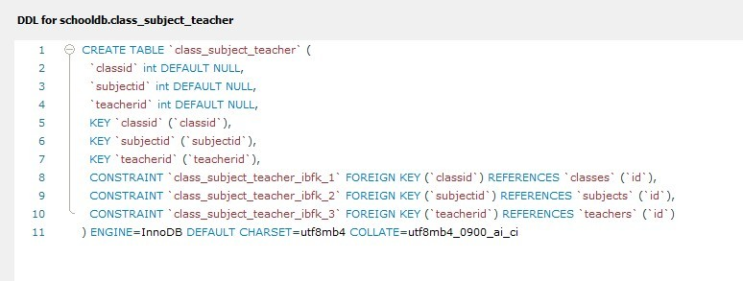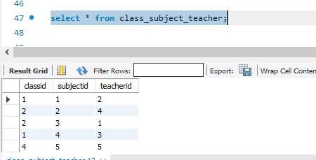

**Classes table:**

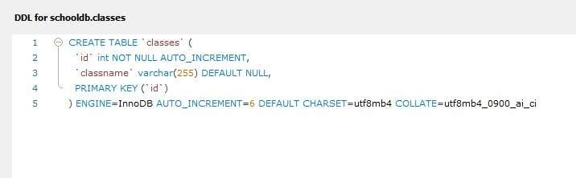

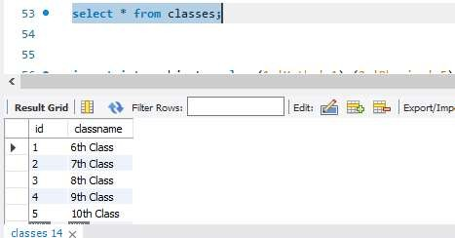

**Students table:**

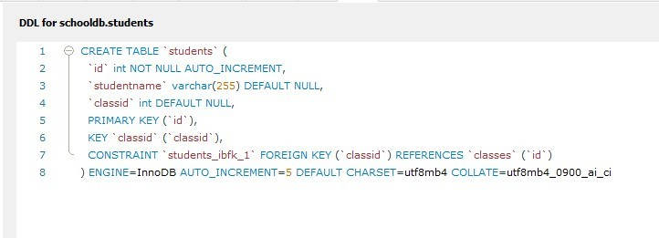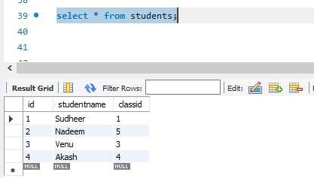

# Project Files:

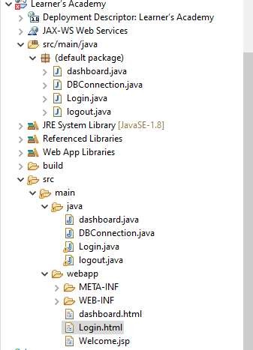

**GitHub Link:** [**https://github.com/sayiri123amulya/LearnersAcademyProject.git**](https://github.com/sayiri123amulya/LearnersAcademyProject.git)

**Conclusion:**

Learner’s Academy Portal helps Admins of the academy to login and can fetch the details of class, such as the list of students, subjects, and teachers.